Age of Heroes

Character & Role Descriptions

These character descriptions are to help you decide who you would like to be in the show. We have tried to get pictures looking as close as we can to what that character will actually look like.
- There are 32 speaking roles.
- It is possible for actors to take 2 or even 3 roles.
- There are many no speaking roles available, if you want to have a second character.

Spektacles |  | Bob
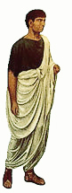 | Chinese: ???  Actor: ♀ or ♂  Speaking:  (284)  Acting:   Dancing:   Born this way (group)  Baby (group)  Singing:   Born this Way (group)  Scenes: 2,5,7,8,9,12,14,15  Personality: 愚蠢 & 認真 | 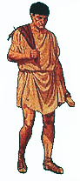 | Chinese: 鮑伯  Actor: ♀ or ♂  Speaking:  (211)  Acting:   Dancing:   Born this way (group)  Baby (group)  Bad Romance (group)  Singing:   Born this Way (group)  Scenes: 2,5,7,8,9,12,14,15  Personality: 勝任 &苦笑著

Zeus |  | Death
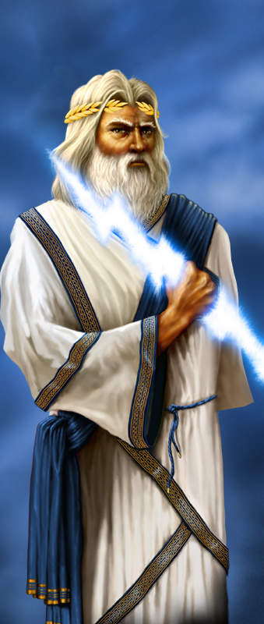 | Chinese: 宙斯  Actor: ♂  Speaking:  (133)  Acting:   Dancing:   Born this way (group)  Singing:   Born this Way (group)  Scenes: 1,3,6,10,13,15  Personality: 令人生畏 & 生氣 | 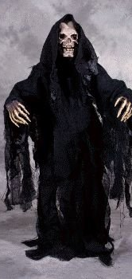 | Chinese: 死神  Actor: ♀ or ♂  Speaking:  (96)  Acting:   Dancing:   Born this way (solo)  Baby (solo)  Singing:   Baby (solo)  Born this Way (solo)  Scenes: 1,2,5,7,8,9,12,14,15  Personality: 隨和 & 熱衷功名

Hera |  | Hades
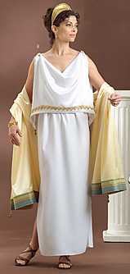 | Chinese: 希拉  Actor: ♀  Speaking:  (107)  Acting:   Dancing:   Born this way (group)  Singing:   Born this way (group)  Scenes: 1,3,4,10,11,13,15  Personality: 渴望權力 & 縱容 | 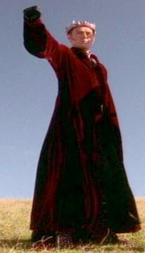 | Chinese: 海地斯  Actor: ♀ or ♂  Speaking:  (83)  Acting:   Dancing:   Born this way (group)  Singing:   Born this Way (group)  Scenes: 1,4,11,15  Personality: 明智 & 不受歡迎
Hercules (LITTLE GIRL) |  | Archimedes
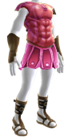 | Chinese: 大力士  Actor: ♀  Speaking: (56)  Acting:   Dancing:   Born this way (group)  Baby (group)  Singing:   Born this Way (group)  Scenes: 7,8,9,12,14,15  Personality: 愚蠢 & 認真 | 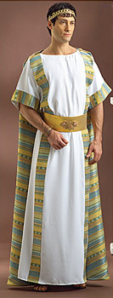 | Chinese: 阿基米德  Actor: ♀ or ♂  Speaking:  (60)  Acting:   Dancing:   Born this way (group)  Baby (group)  Singing:   Born this Way (group)  Scenes: 7,8,9,12,14,15  Personality: 激動的
Aphrodite |  | Argos
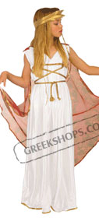 | Chinese: 阿芙蘿黛蒂  Actor: ♀  Speaking:  (61)  Acting:   Dancing:   Born this way (group))  Singing:   Born this Way (group)  Scenes: 1,3,4,6,10,11,13,15  Personality: 38 & 和藹 | 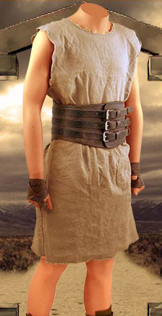 | Chinese: 阿戈斯  Actor: ♀ or ♂  Speaking:  (51)  Acting:   Dancing:   Bad Romance (group)  Baby (group)  Singing: None  Scenes: 5,7,8,9,12  Personality: 驕傲 & 大聲的
Hippocrates |  | Apollo
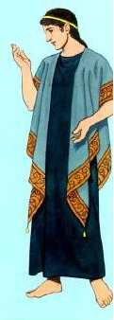 | Chinese: 希波克拉底斯  Actor: ♀ or ♂  Speaking:  (50)  Acting:   Dancing:   Born this way (group)  Baby (group)  Singing:   Born this Way (group)  Scenes: 7,8,9,12,14,15  Personality: 熱情 & 不敏感的 | 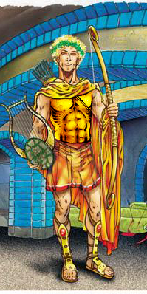 | Chinese: 阿波羅  Actor: ♀ or ♂  Speaking:  (51)  Acting:   Dancing:   Born this way (group)  Singing:   Born this Way (group)  Scenes: 1,3,6,10,13,15  Personality: 華麗的 & 容易無聊
Athena |  | Hermes
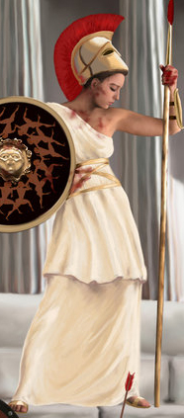 | Chinese: 雅典娜  Actor: ♀  Speaking:  (47)  Acting:   Dancing:   Born this way (group)  Singing:   Born this Way (group)  Scenes: 1,3,4,6,10,11,13,15  Personality: 憂鬱 & 叛逆 | 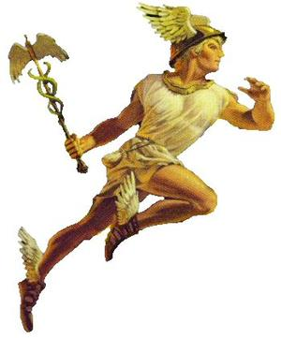 | Chinese: 愛瑪仕  Actor: ♀ or ♂  Speaking:  (39)  Acting:   Dancing:   Born this way (group)  Singing:   Born this Way (group)  Scenes: 2,5,7,8,12,14,15  Personality: 慌張
Artemis |  | Ares
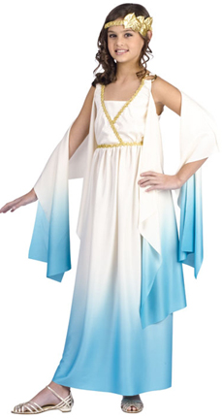 | Chinese: 阿提米斯  Actor: ♀  Speaking:  (33)  Acting:   Dancing:   Born this way (group)  Singing:   Born this Way (group)  Scenes: 1,3,10,13,15  Personality: 憤世嫉俗的 | 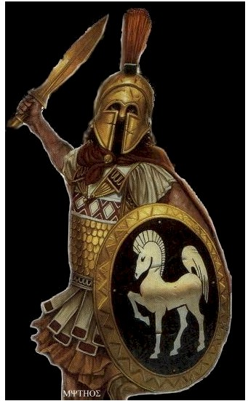 | Chinese: 阿瑞斯  Actor: ♂  Speaking:  (19)  Acting:   Dancing:   Born this way (group)  Singing:   Born this Way (group)  Scenes: 1,3,6,10,13,15  Personality: 男子氣
Jason |  | Oracle
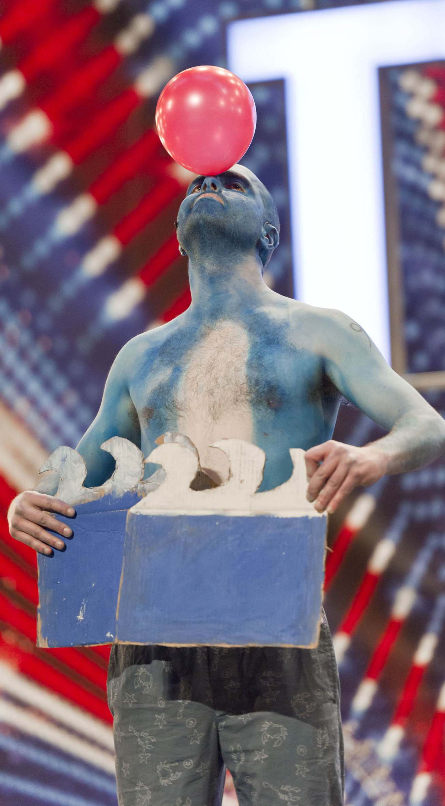 | Chinese: 賈森  Actor: ♂  Speaking:  (23)  Acting:   Dancing: None  Singing: None  Scenes: 6,8,9,12  Personality: 懦弱的 & 藍色的 | 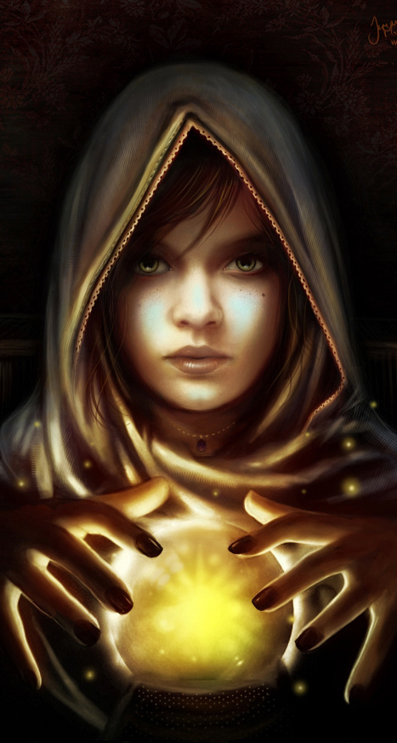 | Chinese: 祭司  Actor: ♀  Speaking:  (27)  Acting:   Dancing:   Bad Romance (solo)  Singing: ?????  Bad Romance (???)  Scenes: 5  Personality: 神秘 & 會大聲的笑
Mario |  | Medusa
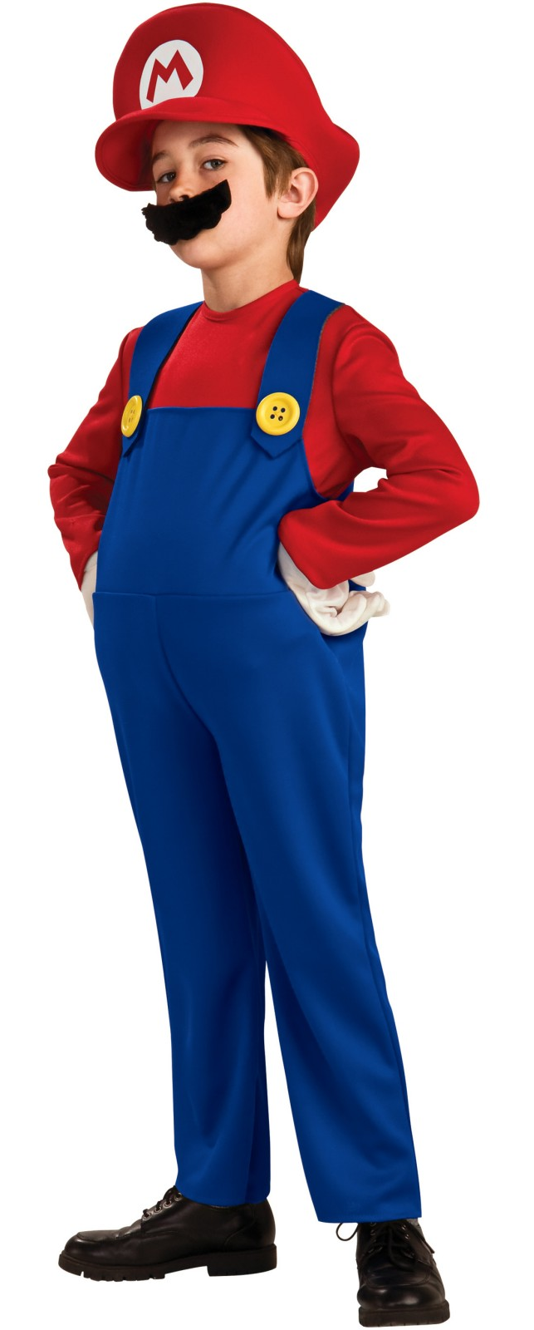 | Chinese: 馬里奧  Actor: ♀ or ♂  Speaking:  (14)  Acting:   Dancing: None  Singing: None  Scenes: 6,8,9  Personality: 有活力的 | 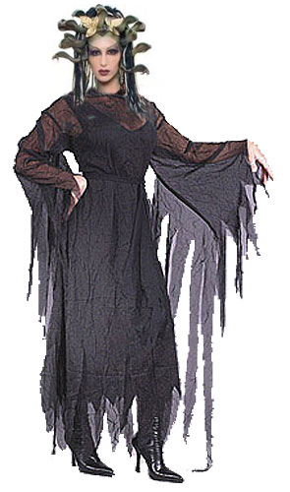 | Chinese: 梅杜莎  Actor: ♀  Speaking:  (13)  Acting:   Dancing: None  Singing: None  Scenes: 12  Personality: 恐怖的 & 巫婆
Homer |  | Princess Helen (Scene 2)
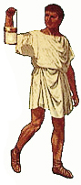 | Chinese: 荷馬  Actor: ♀ or ♂  Speaking:  (13)  Acting:   Dancing: None  Singing: None  Scenes: 6,8,9  Personality: 輕蔑的 | 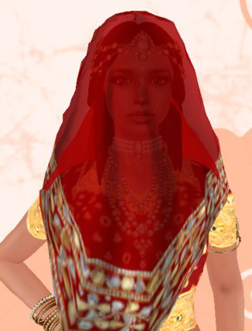 | Chinese: 公主海倫  Actor: ♀  Speaking:  (20)  Acting:   Dancing: None  Singing: None  Scenes: 2  Personality: 富豪& 溫和
Achilles |  | Dionysus
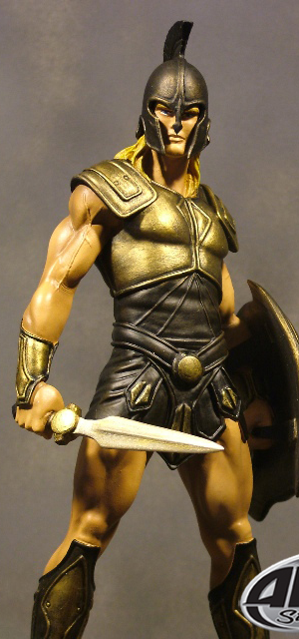 | Chinese: 阿基里斯  Actor: ♂  Speaking:  (4)  Acting:   Dancing: None  Singing: None  Scenes: 7  Personality: 驕傲的 & 戰士 | 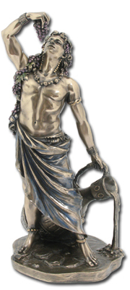 | Chinese: 狄俄尼索斯  Actor: ♂  Speaking:  (9)  Acting:   Dancing:   Born this way (group)  Singing:   Born this Way (group)  Scenes: 1,3,6,10,13,15  Personality: 愛好樂趣 & 醉
Poseidon |  | Demeter
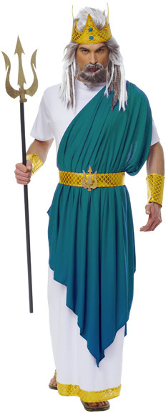 | Chinese: 波塞頓  Actor: ♀  Speaking:  (17)  Acting:   Dancing:   Born this way (group)  Singing:   Born this Way (group)  Scenes: 1,3,6,10,13,15  Personality: 支持宙斯 | 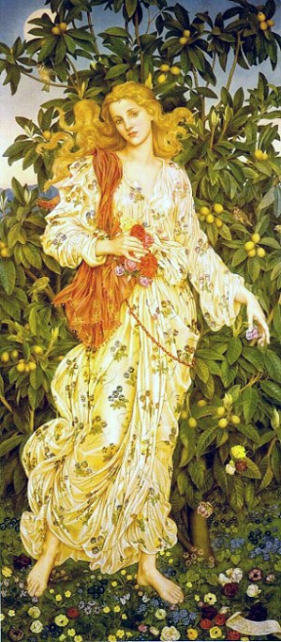 | Chinese: 迪米特  Actor: ♀  Speaking:  (7)  Acting:   Dancing:   Born this way (group)  Singing:   Born this Way (group)  Scenes: 1,3,6,10,13,15  Personality: 寧靜 & 深思熟慮
Angel |  | Elise
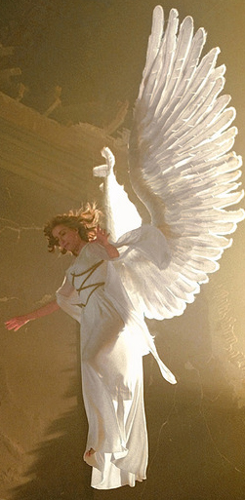 | Chinese: 守護天使  Actor: ♀ or ♂  Speaking:  (12)  Acting:   Dancing: None  Singing: None  Scenes: 12,14  Personality: 神聖的& 祥和的 | 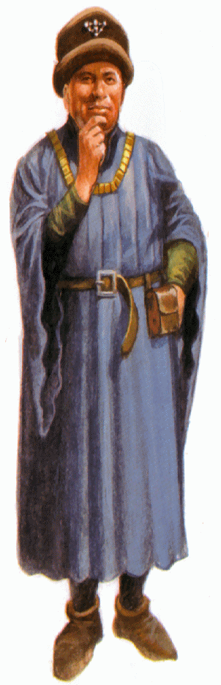 | Chinese:  Actor: ♀ or ♂  Speaking:  (21)  Acting:   Dancing: None  Singing: None  Scenes: 2  Personality: 街頭智慧 & 賭俠
Princess Helen (Scene 15) |  | Herald
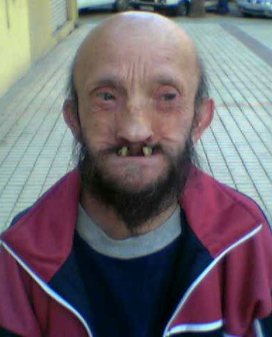 | Chinese: 公主海倫  Actor: ♀ or ♂  Speaking:  (3)  Acting:   Dancing:   Born this way (group)  Singing:   Born this Way (group)  Scenes: 15  Personality: 醜陋的 | 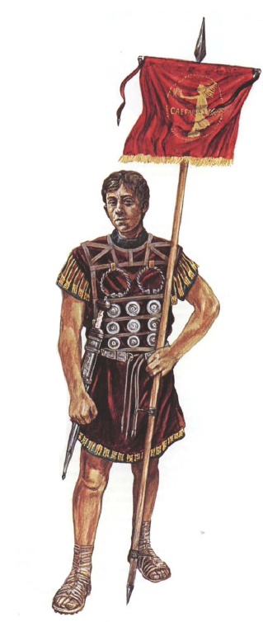 | Chinese: 使者  Actor: ♀ or ♂  Speaking:  (14)  Acting:   Dancing: None  Singing: None  Scenes: 2  Personality: 非官方的 & 宦官
UPS Courier |  | Newsboy
 | Chinese: UPS的信使  Actor: ♀ or ♂  Speaking:  (4)  Acting:   Dancing: None  Singing: None  Scenes: 12  Personality: 公事公辦 | 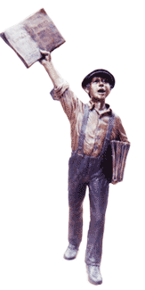 | Chinese:  Actor: ♀ or ♂  Speaking:  (1)  Acting:   Dancing:   Bad Romance (???)  Singing: None  Scenes: 5  Personality:
Princess Helen (Scene 2)

